Receiving

# ERD for UX process

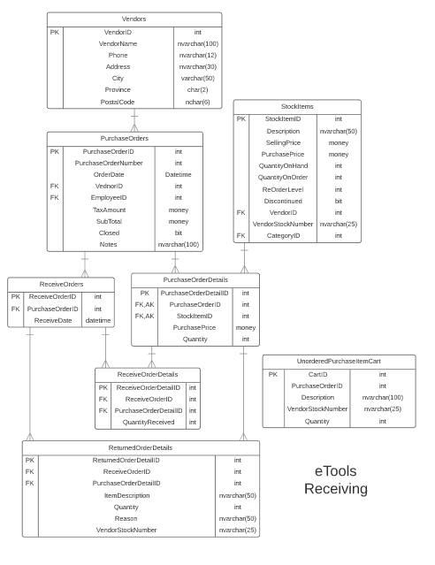

# Possible UX Interface

# Event and Wiring Summations

|  |  |  |
| --- | --- | --- |
| **Controls** | | **Events** |
| Outstanding orders ListView | | None/ wired via ObjectDataSource |
| **BBL Class(es) and Method (s)** | | |
| PurchaseOrderController | List<VendorPurchaseOrder>List_OutstandingOrders()  Retrieve a list of vendors and purchase orders with PO numbers and PO dates with closed attribute set to false for ListView | |
| **SQL Table(s): (C,R,U,D)** | | **Entities/DTOs/POCOs** |
| PurchaseOrders (R), Vendors(R) | | VendorPurchaseOrder(P) |

|  |  |  |
| --- | --- | --- |
| **Controls** | | **Events** |
| Outstanding orders select link button (POID), receive order detail ListView | | Select (Outstanding orders ListView) OnClick   * Find order detail by selected orderID * Display order details in receive order detail ListView * Display selected purchase order number |
| **BBL Class(es) and Method (s)** | | |
| PurchaseOrderDetailController | List<PurchaseOrderStockDetail> List_OutstandingOrderDetail(int orderID)  Retrieve a list of order details for selected orderID | |
| **SQL Table(s): (C,R,U,D)** | | **Entities/DTOs/POCOs** |
| PurchaseOrderDetails(R), StockItems(R) | | PurchaseOrderStockDetail(P) |

|  |  |  |
| --- | --- | --- |
| **Controls** | | **Events** |
| Delete (UnorderedPurchaseItemCart) button, CartID | | Delete OnClick   * Delete UnorderedPurchaseItemCart entry by CartID |
| **BBL Class(es) and Method (s)** | | |
| UnorderedPurchaseItemCartController | void Delete_UnorderedPurchaseItemCart(int CartID)  TRX(find and remove item by CartID) | |
| **SQL Table(s): (C,R,U,D)** | | **Entities/DTOs/POCOs** |
| UnorderedPurchaseItemCart (D) | | UnorderedPurchaseItemCart(E) |

|  |  |  |
| --- | --- | --- |
| **Controls** | | **Events** |
| Submit (ReceiveOrderDetails, ReturnOrderDetails) button, QuantityReceived textbox, Quantity(Returned) textbox, Reason(Returned) textbox | | OnClick   * Collect receive order details and return order details and validate data * Send to BLL to update ReceiveOrderDetails, ReceiveOrders, StockItems and ReturnedOrderDetails and PurchaseOrder(opt) * Refresh Screen (including empty cart) |
| **BBL Class(es) and Method (s)** | | |
| ReceiveReturnOrderController | void Add_ReceiveReturnOrders (int PurchaseOrderID, int PurchaseOrderDetailID, int QuantityReceived, List<ReturnedOrderDetails> ReturnedOrderDetails, List<UnorderedPurchaseItemCart> UnorderedPurchaseItems)  TRX(create ReceiveOrders entry, create ReceiveOrderDetail entry, create ReturnedOrderDetail entry for both UnorderedPurchaseItems and for damaged/refused items update StockItems quantities, close PurchaseOrder if all quantities outstanding have been received, empty cart) | |
| **SQL Table(s): (C,R,U,D)** | | **Entities/DTOs/POCOs** |
| ReceiveOrderDetails(C), ReturnedOrderDetails(C), PurchaseOrders(U opt), ReceiveOrders(C), StockItems(U), UnorderedPurchaseItemCart (C), PurchaseOrderDetails(R) | | ReceiveOrderDetails(E), ReturnedOrderDetails(E), ReceiveOrders(E), StockItems(E), UnorderedPurchaseItemCart (E), PurchaseOrderDetails(E) |

|  |  |  |
| --- | --- | --- |
| **Controls** | | **Events** |
| Add (UnorderedPurchaseItemCart) button, Description textbox, VendorStockNumber textbox, Quantity textbox, PurchaseOrderID | | Add OnClick   * Create UnorderedPurchaseItemCart entry * Use same POID as selected PurchaseOrder |
| **BBL Class(es) and Method (s)** | | |
| UnorderedPurchaseItemCartController | void Add_UnorderedPurchaseItemCart(string Description, string VendorStockNumber, int Quantity, int PurchaseOrderID)  TRX(Add item to cart by PurchaseOrderID) | |
| **SQL Table(s): (C,R,U,D)** | | **Entities/DTOs/POCOs** |
| UnorderedPurchaseItemCart (C) | | UnorderedPurchaseItemCart(E) |

|  |  |  |
| --- | --- | --- |
| **Controls** | | **Events** |
| Cancel button | | Cancel OnClick   * Remove all UnorderedPurchaseItemCart * Clear receive/return entry fields * Return to outstanding orders screen |
| **BBL Class(es) and Method (s)** | | |
| UnorderedPurchaseItemCartController | void Clear_UnorderedPurchaseItemCart(int PurchaseOrderID)  TRX(find and remove item(s) by PurchaseOrderID) | |
| **SQL Table(s): (C,R,U,D)** | | **Entities/DTOs/POCOs** |
| UnorderedPurchaseItemCart (D) | | UnorderedPurchaseItemCart(E) |

|  |  |  |
| --- | --- | --- |
| **Controls** | | **Events** |
| Force Close button, PurchaseOrderID | | Force Close OnClick   * Set PurchaseOrder closed status to true * Record reason for force close in PurchaseOrder Notes * Subtract QuantityOutstanding from QuantityOnOrder * Return to outstanding orders screen |
| **BBL Class(es) and Method (s)** | | |
| PurchaseOrderController | void ForceClose_PurchaseOrder(string Reason, int PurchaseOrderID)  TRX(Update PurchaseOrder status, update PurchaseOrder notes, update StockItem QuanitityOnOrder) | |
| **SQL Table(s): (C,R,U,D)** | | **Entities/DTOs/POCOs** |
| PurchaseOrders(U), StockItems(U), PurhcaseOrderDetails(R) | | PurchaseOrders, PurchaseOrderDetails |

|  |  |  |
| --- | --- | --- |
| **Controls** | | **Events** |
| Update (UnorderedPurchaseItemCart) button, PurchaseOrderID, CartID | | Update OnClick   * Update UnorderedPurchaseItemCart entry by CartID |
| **BBL Class(es) and Method (s)** | | |
| UnorderedPurchaseItemCartController | void Update_UnorderedPurchaseItemCart(string Description, string VendorPartNumber, int Quantity, int PurchaseOrderID, int CartID)  TRX(match cart to existing CartID and make changes) | |
| **SQL Table(s): (C,R,U,D)** | | **Entities/DTOs/POCOs** |
| UnorderedPurchaseItemCart (U) | | UnorderedPurchaseItemCart(E) |